**Heading:**

* Document name: "Sprint 1 Plan"
* Product name: Sandwich Story
* Team name: “The Sandwich Guys”
* Sprint Completion date: July 10th, 2017
* Revision number: Revision 1
* Revision date:July 3rd, 2017

**Goals:**

1. Have the framework for the entire app laid out: The 6 activity pages and non-working buttons for each page
2. Have an interactive UI for each activity: make each button/text box function
3. Have ability to switch between activities: add intents to different activities via buttons

**Task listing, organized by user story:**

* User Story 1: As a user, I would like to access a list of my saved recipes so I can recall my desired recipes at any time.
  + Task 1: Create the home page activity, layout the basics of the activity (1 ideal hour)
  + Task 2: Allow user to choose a recipe from the home page and open the sandwich detail activity to see the recipe (3 ideal hours)
  + Task 3: Implement a grid view. (6 ideal hours)
  + Task 4: Store the user’s saved recipes locally on the device (1 ideal hour)

**Total for user story 1: 11 ideal hours**

* User Story 2: As a user, I would like to be able to create new recipes with my own ingredients so that I can save recipes I have made myself.
  + Task 1: Create activity where the user can create a recipe though interactive customization options (Layout the basics of the activity) (6 ideal hours)
  + Task 2: Create drop down lists for adding ingredients (2 ideal hours)
  + Task 3: Store the user’s newly created recipe locally on their device.(1 ideal hour)
  + Task 4: Allow the user to add a photo from the user’s personal device to their recipe (2 ideal hours)

**Total for user story 2: 11 ideal hours**

* User Story 3: As a user, I would like to able to edit my recipes so that I can make modifications to recipes if needed.
  + Task 1: Fill the textboxes on the “add recipe” activity with the details of the recipe that the user is editing. (2 ideal hours)
  + Task 2: Update the values stored in the phone for the corresponding recipe I’ve edited (2 ideal hours)

**Total for user story 3: 4 ideal hours**

* User Story 4: As a user, I would like to be able to delete recipes so that I may remove recipes I no longer have interest in.
  + Task 1: Implement UI for deleting a recipe (3 ideal hours)
  + Task 2: Reflect the deletion in the recipes saved to the user’s device (2 ideal hours)

**Total for user story 2: 5 ideal hours**

* User Story 5: As a user, I would like to be able to share my recipes so I can show my creativity with other users.
  + Task 1: Have the ability to access pre-existing data via downloading from the server (6 ideal hours)
  + Task 2: Have the ability to save recipes to the database (5 ideal hours)

**Total for user story 2: 11 ideal hours**

**Team Roles:**

Alex Williamson - Product Owner, Front-End Developer, Backend Developer

David Stewart - Front-End Developer, Backend Developer

Chris Hahn - Scrum Master, Front-End Developer, Backend Developer

Celine Peña - Front-End Developer

Davie Truong - Front-End Developer

Matthew Diep - Front-End Developer

**Initial Task assignment:**

Alex Williamson - User Story 5: Task 1

David Stewart - User Story 5: Task 1

Chris Hahn - User Story 5: Task 2

Celine Peña - User Story 2: Task 1,2

Davie Truong - User Story 1/4: Tasks 2/4 (respectively)

Matthew Diep - User Story 2/3: Tasks 3,4/1 (respectively)

**Initial Burnup chart:**

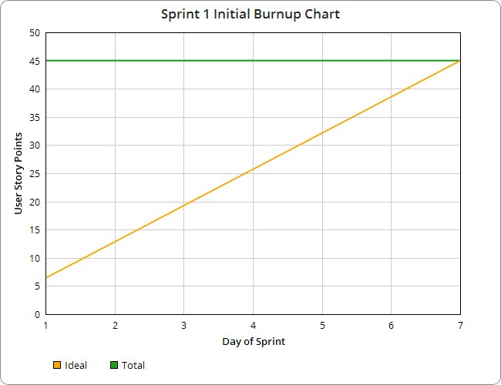

**Initial scrum board:**

|  |  |  |  |
| --- | --- | --- | --- |
| **User Story** | **To Do** | **In Progress** | **Done** |
| As a user, I’d like to access a list of my saved recipes so I can recall my desired recipes at any time | |  | | --- | | Create the home page activity (layout the basics of the activity) |  |  | | --- | | Allow user to choose a recipe from the home page and open the sandwich detail activity to see the recipe |  |  | | --- | | Implement a GridView to contain the recipes |  |  | | --- | | Store the user’s saved recipes on their device | |  |  |
| As a user, I’d like to be able to create new recipes with my own ingredients so that I can save recipes I have made myself | |  | | --- | | Create activity where the user can create a recipe though interactive customization options |  |  | | --- | | Create drop down lists for adding ingredients |  |  | | --- | | Store the user’s newly created recipe on their device |  |  | | --- | | Allow the user to upload a photo from their device to save with their recipe | |  |  |
| As a user, I’d like to be able to edit my recipes so that I can make modifications to recipes if needed | |  | | --- | | Fill the text boxes on the “add recipe” activity with the details of the recipe that the user is editing |  |  | | --- | | Update the values stored on the phone for the corresponding recipe the user has edited | |  |  |
| As a user, I’d like to be able to delete recipes so that I may remove recipes I no longer have interest in | |  | | --- | | Implement UI for deleting a recipe (buttons) |  |  | | --- | | Reflect the deletion in the recipes saved on the user’s device | |  |  |
| As a user, I’d like to be able to share my recipes so I can show my creativity with other users | |  | | --- | | Have the ability to access pre-existing data via downloading from the server |  |  | | --- | | Have the ability to upload recipes to the database | |  |  |

**Scrum times:**

* Tuesday 12:30-2:30pm
* Thursday 12:30-2:30pm
* Sunday 2:30-5:30pm